**PIZZA SALES SQL QUERIES**

**A.KPI,s**

**1. Total Revenue**

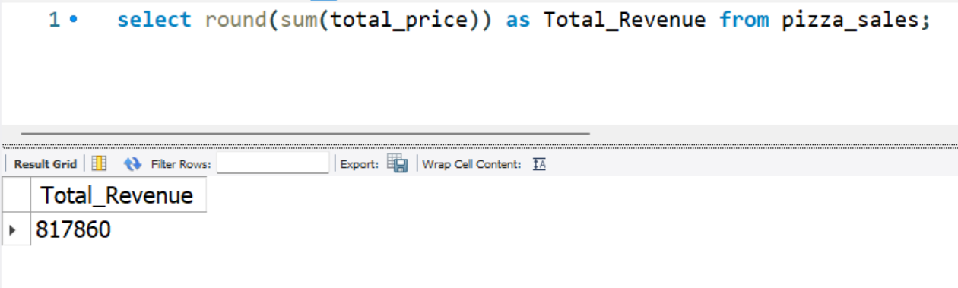

**2. Average Order Value**

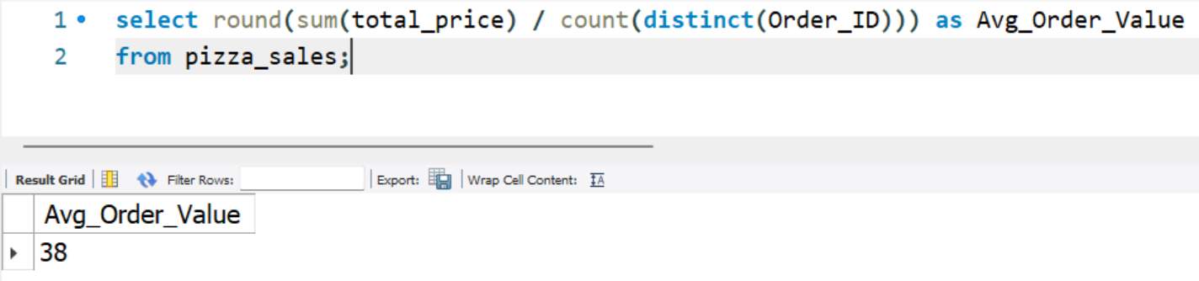

**3. Total Pizza Sold**

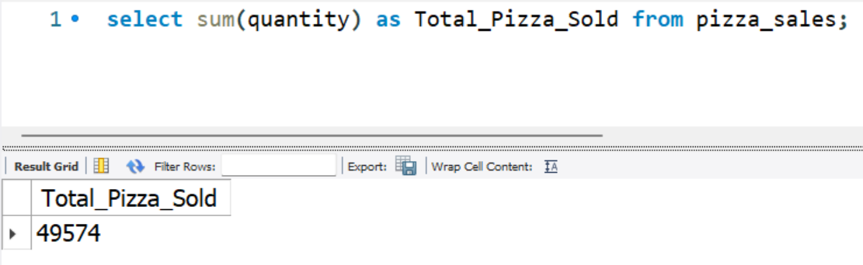

**4. Total Orders**

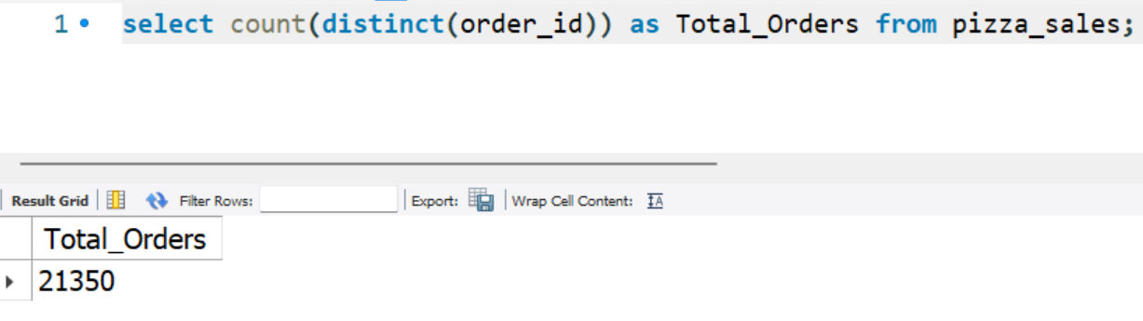

**5. Average Pizzas Per Order**

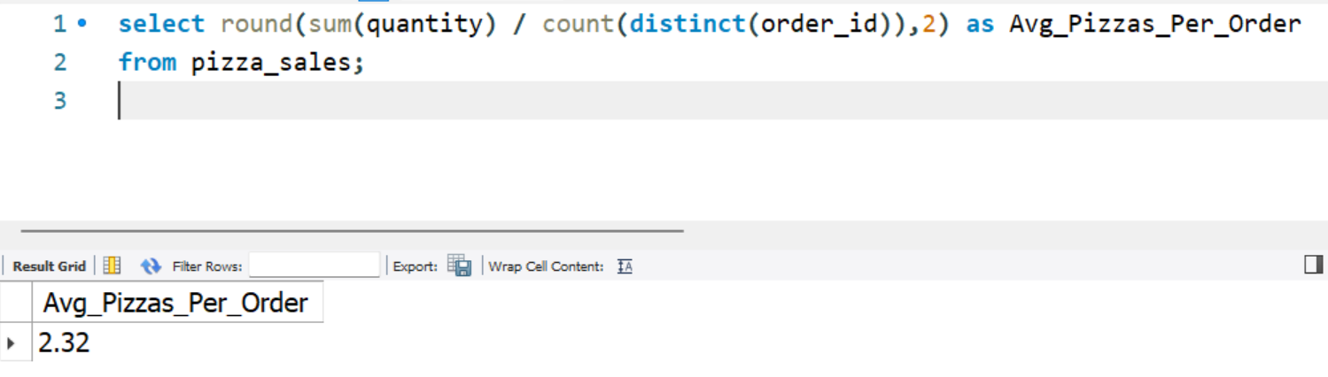

**B. Daily Trend for Total Orders**

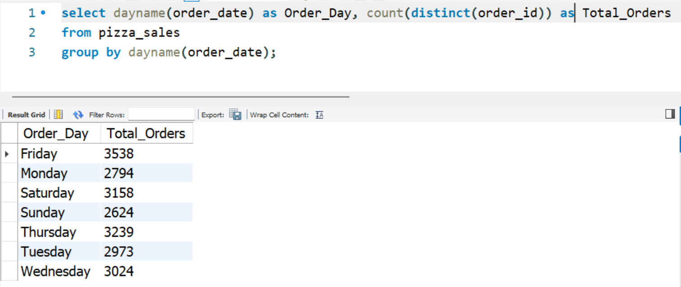

**C. Monthly Trend for Orders**

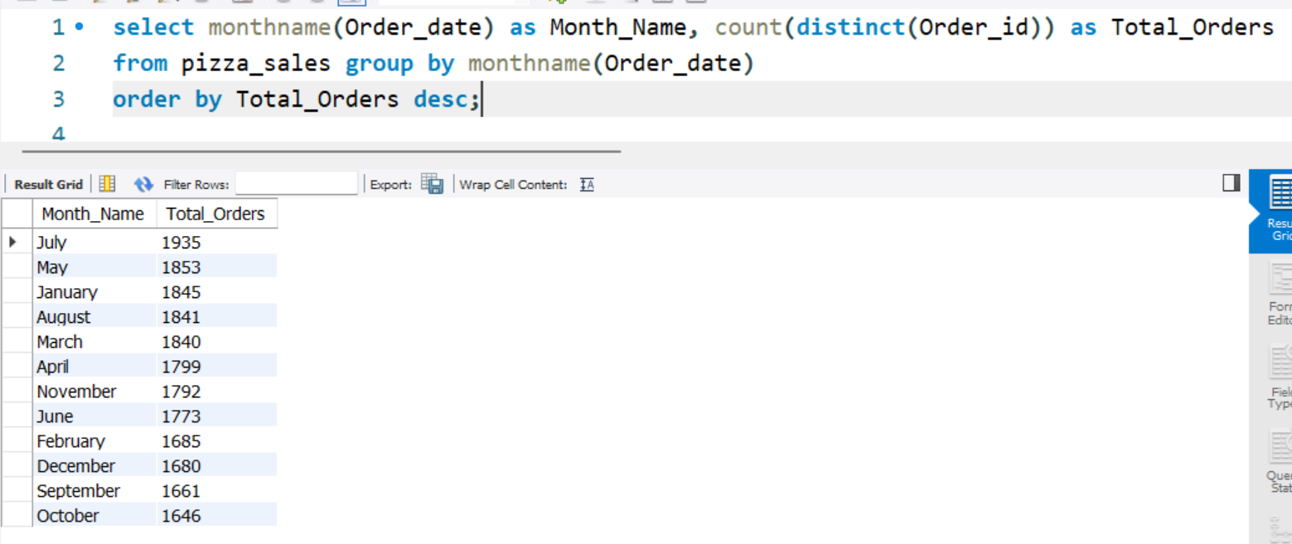

**D. % of Sales by Pizza Category**

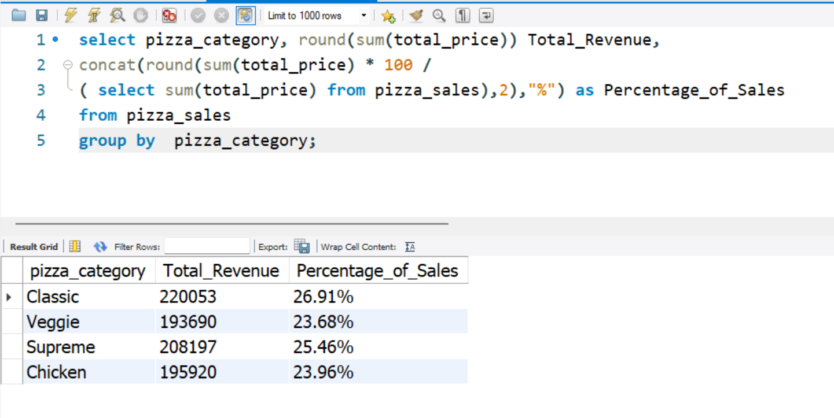

**E. % of Sales by Pizza Size**

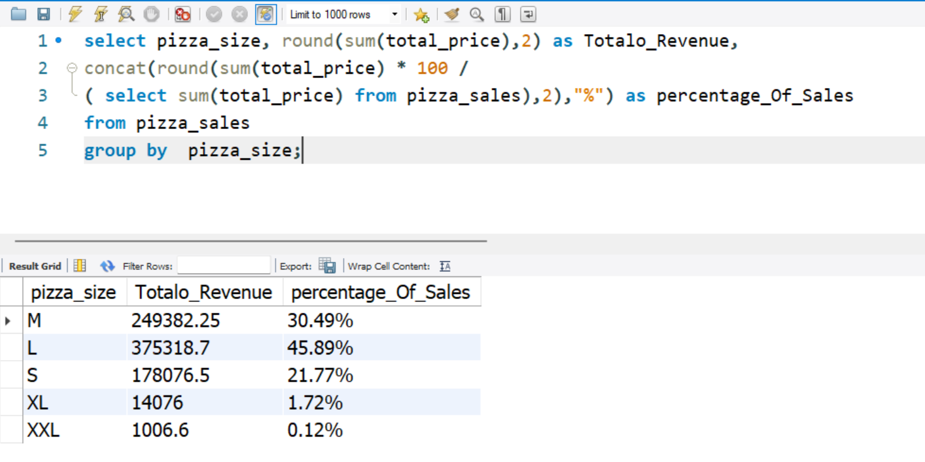

**F. Total Pizzas Sold by Pizza Category**

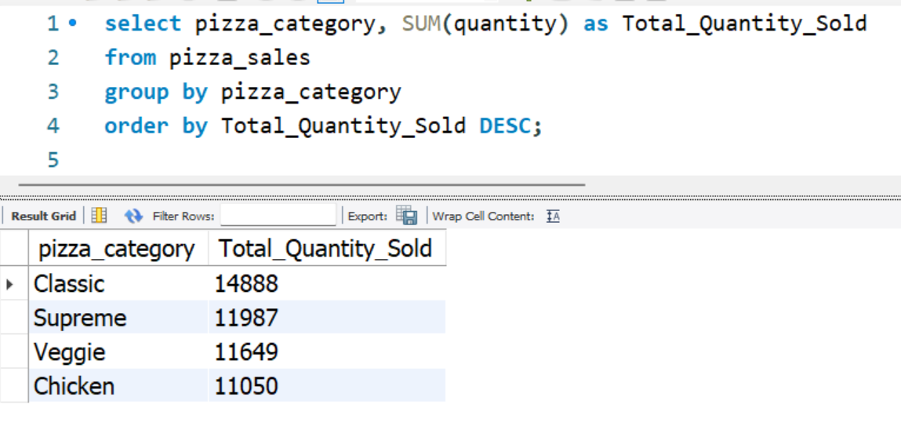

**G. Top 5 Pizzas by Revenue**

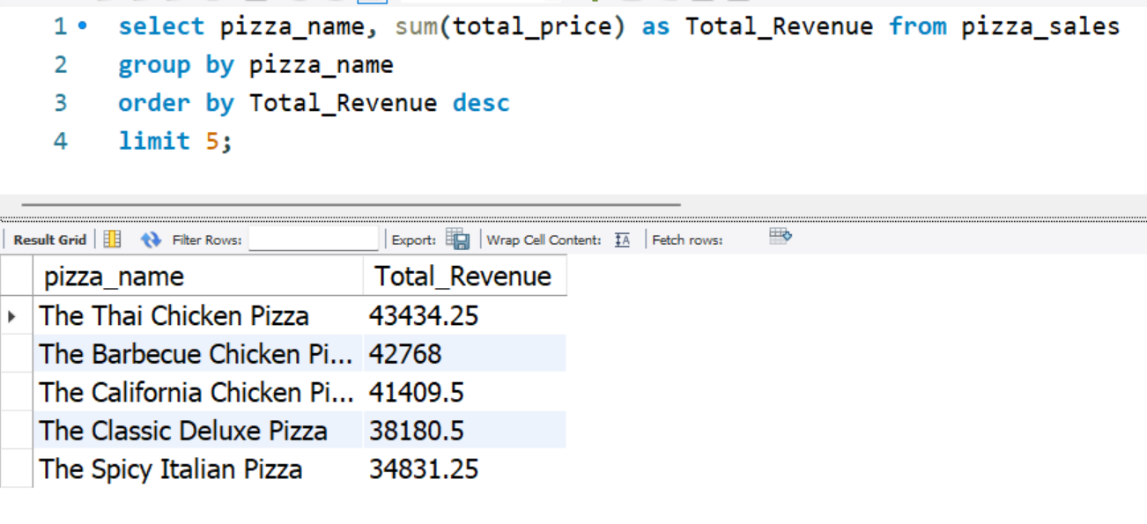

**H. Bottom 5 Pizzas by Revenue**

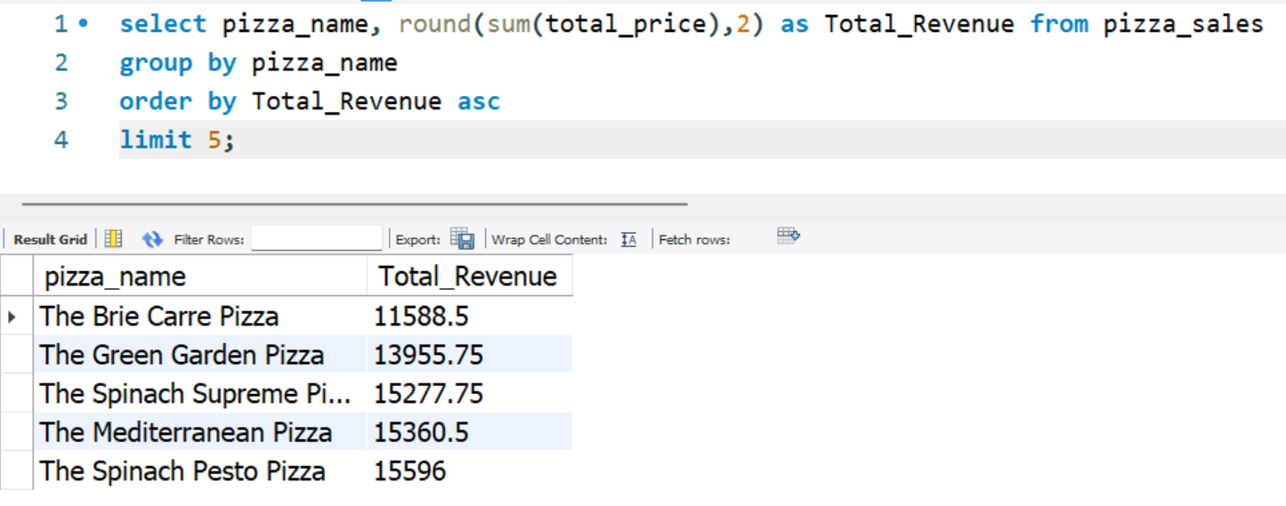

**I.Top 5 Pizzas by Quantity** 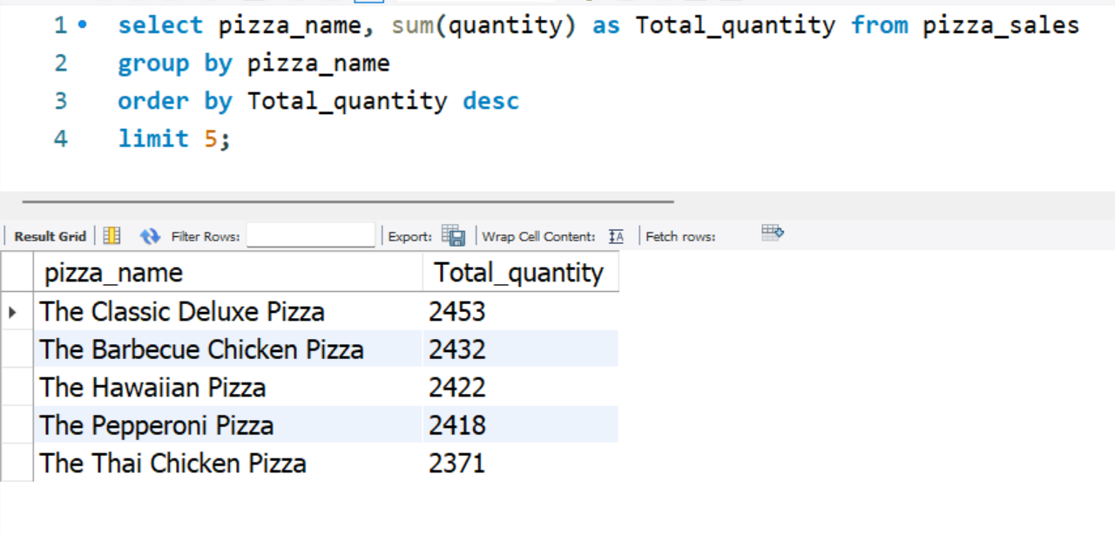

**J. Bottom 5 Pizzas by Quantity**

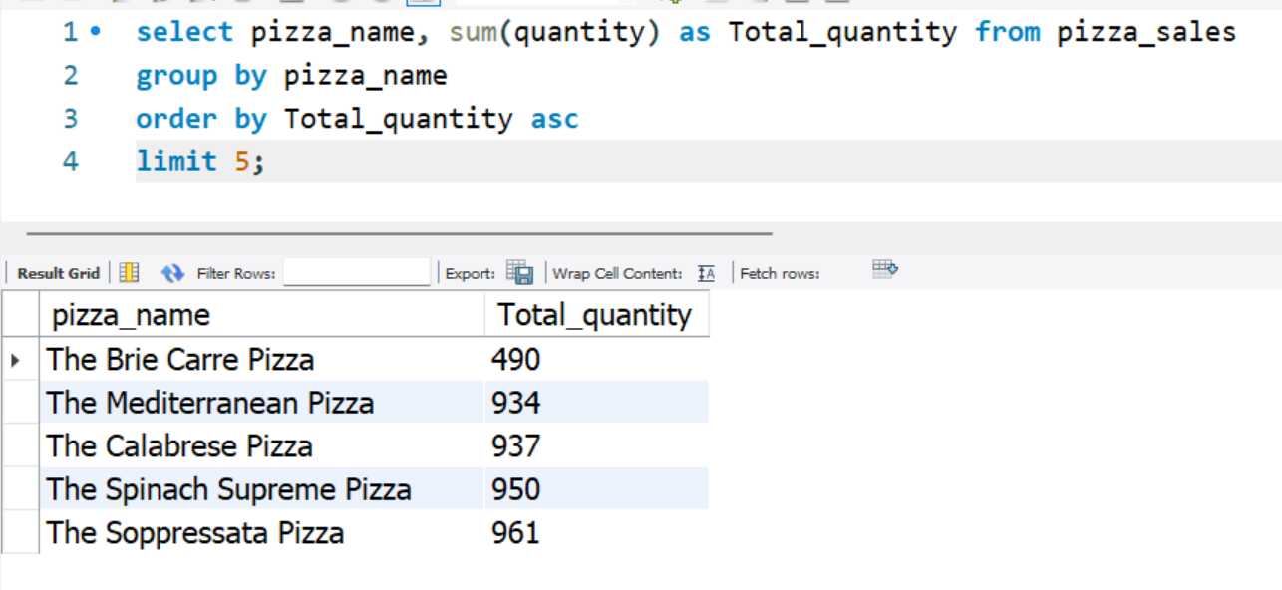

**K. Top 5 Pizzas by Total Orders**

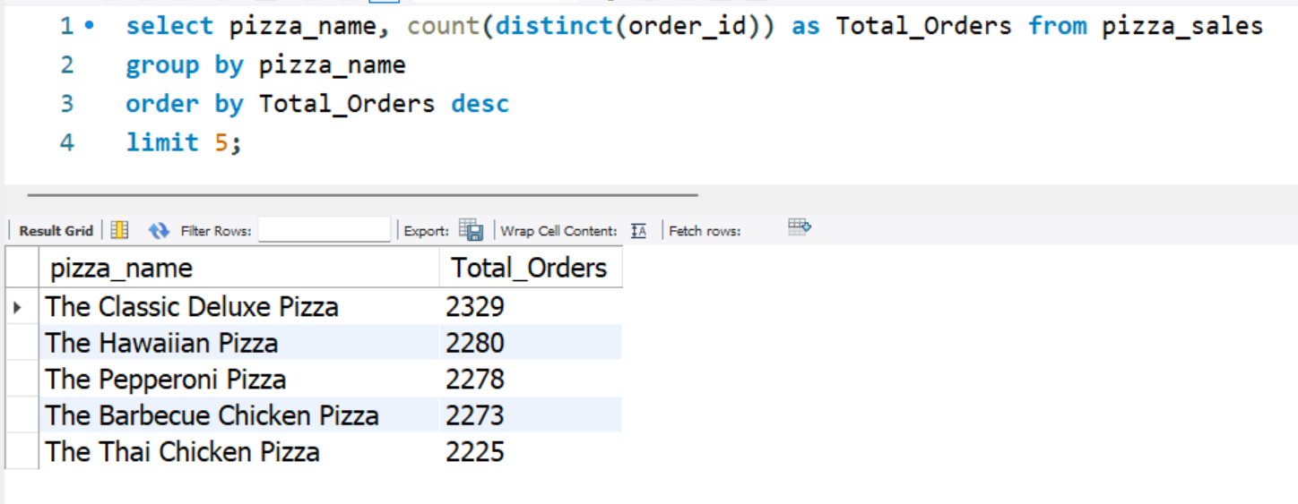

**L. Bottom 5 Pizzas by Total Orders**

